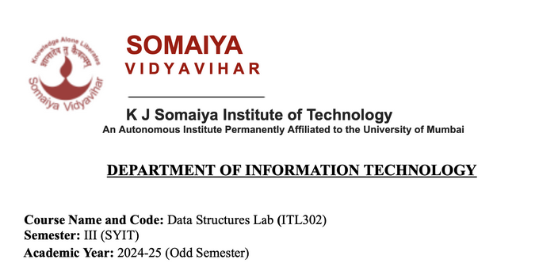

**Experiment NO.6**

**Aim:**Implementation of Binary Tree and its Traversal for real-world application.

**Code:**

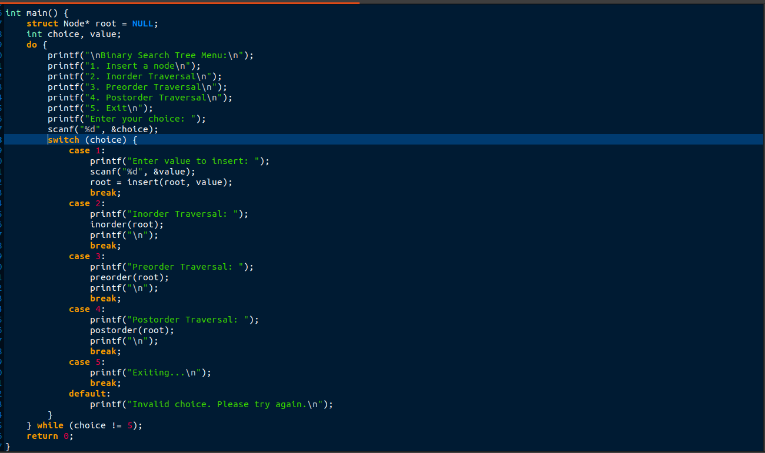

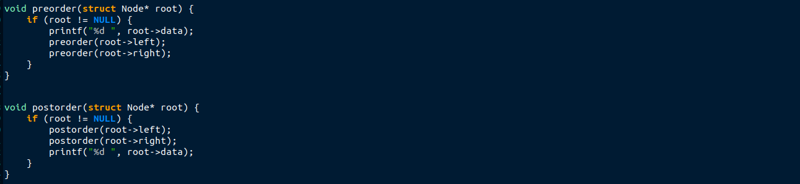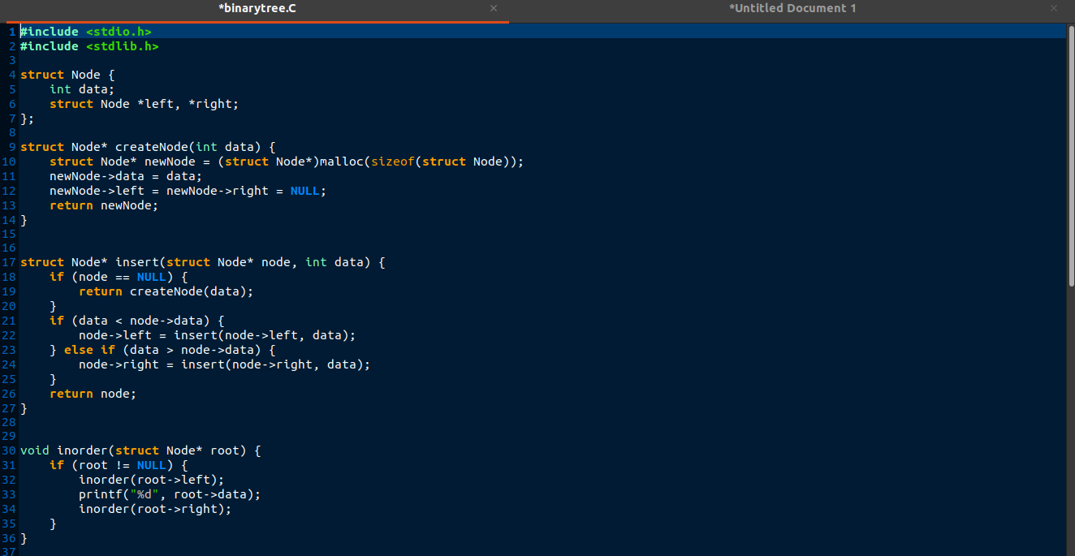

**Output:**

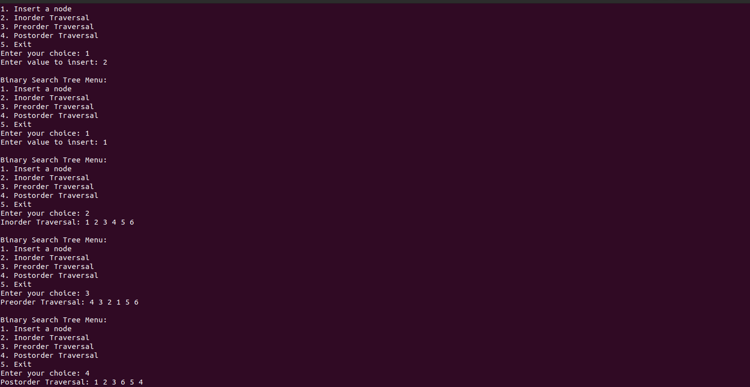

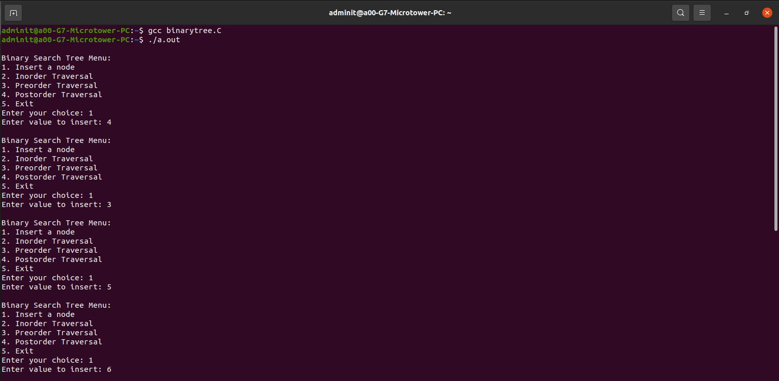

**Submitter Details:**

**Name:Yash.M.Dharamshi**

**Roll no:22**

**Date of permission:20/9/2024**

**Date of Submission:20/9/2024**